CONTENTS OF MICRO- AND MACROELEMENTS IN LIVER IN THE CONDITIONS OF DEVELOPING CHRONIC ALCOHOL INTOXICATION
Stepanets Inna Alexandrovna
postgraduate, Educational and scientific center “Institute of Biology”
of T. Shevchenko Kiev National University, Kiev
Maximovich Yaroslava Sergeevna
Candidate of Biological Sciences, junior research associate,
Educational and scientific center “Institute of Biology”
of T. Shevchenko Kiev National University, Kiev
Kudryavtseva Alla Grigoryevna
Candidate of Biological Sciences, scientific researcher, the Agroindustrial Complex, Kiev
Ostapchenko Lyudmila Ivanovna
Doctor of Biological Science,professor,
T. Shevchenko Kiev National University, Kiev

E-mail: stepanetsinna@bigmir.net

Introduction

Alcoholism is one of the main issues of the modern society. Alcohol consumption has a toxic effect on a number of organs, has a negative influence on the activity of all systems of the body, metabolic processes, water-electrolytic balance, decreases the contents of Sodium, Calcium, Potassium and Chlorine in a body [1, 7]. The essential microelements, such as Zinc and Copper, as well as macroelement Magensium play an important roles in metabolic processes [17]. Zinc was detected in over 300 enzymes [12]. It actively participated in the anti-oxidizing protection, stabilizes the cytoskeleton and membranes, and is a structural component of superoxide dismutase. Besides, such a microelement has been detected to probably be an antiapoptotic agent, secondary messenger and neuromediator, being an important co-factor in DNA synthesis and plays a substantial role in the immune system. Moreover, the main enzymes of ethanol metabolism contain zinc atoms which makes stydying of the zinc role in ethanol action current and prospective [12, 18, 19].
Copper is a microelement required for an organism growth, normal functioning of the immune system and antioxidant protection, maturation, blood cells, glucose and cholesterol metabolism, development and functioning of the brain tissues and myocardium contractions [14, 16].
Magnesium is one of the most important macroelements, because it takes part in many physiological processes, stabilizes the cell membranes, transmembrane transfer of Calcium and Sodium ions, as well as metabolic reactions of formation, accumulation and utilization of energy, free radicals and products of their oxidation products. Magnesium ions comprise 13 metalloproteins and over 300 enzymes. Magnesium takes part in DNA synthesis processes, transfer of genetic information, proteins-, fat- and carbohydrate exchange, oxidizing phospholyration etc. [3, 9].
That is why the object of our work was to study the contents of Zinc, Magnesium and Copper in the rats liver tissue in the conditions of chronic alcohol intoxication.
Materials and methods of investigation
The investigations were conducted on outbred rats (males) with a body weight of 180—200 g, fed with the standard food ration of the vivarium with a free access to water. The animals were divided in 2 groups: 1 group – intact animals (control); 2 group – rats with the chronic alcohol intoxication (caused by daily intragastral administration of ethanol (46 %) for 28 days by 2 ml per 100 g of the animal body weight per day) [13]. The liver tissues were obtained according to the recommendations of the standard method on the 14, 28 days [15]. The investigations are compliant with the main requirements in relation to management and work with laboratory animals according to the Regulations of the European Convention for the Protection of Animals, used in experimental investigations and other scientific purposes (Strasburg, 1986). Contents of the investigated microelements was detected using the atomic emission spectrometer “IRIS Intepid II XDL” (ICP AES). The statistical processing of results was performed using Student`s t-criterion in Р<0.05.

Discussion of the investigation results
We have found out that in the long-term ethanol influence, the contents of Zinc, Magnesium and Copper in liver change (Fig. 1.).

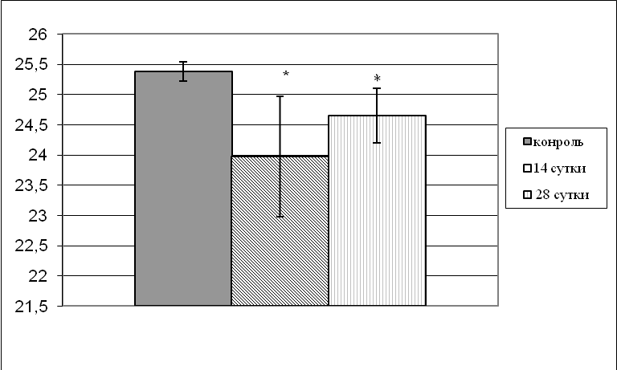
* – Р≤0.05 – in comparison to the control
Control
The 14-th day
The 28-th day
Fig. 1. Zinc contents in the rats liver in administration of ethanol in the conditions of the chronic alcohol intoxication development on the 14 and 28 days after ethanol administration.

Our investigations show that administration of ethanol led to decrease of zinc contents in liver by 94 %, 97 % in 14 and 28 days, respectively. From the literature data, the alcohol intoxication development is known to be accompanied by zinc deficit in many organs, which may be a reason of many enzymes malfunction, including those responsible for ethanol metabolism, because it stabilizes its structure due to binding with the SH-groups [2, 10]. The zinc level decrease leads to decrease of T-lymphocytes production, thymalinum synthesis (zinc-dependent thymus hormone), inhibition of interleukin production, γ-interferon, tumor necrosis factor. Insufficient contents of such a microelement blocks transfer from one phase of the cell cycle to the other. Zinc metabolism change leads to malfunction of the antioxidant system of hepatocytes, that increases the damaged liver development risk [21, 22, 4].
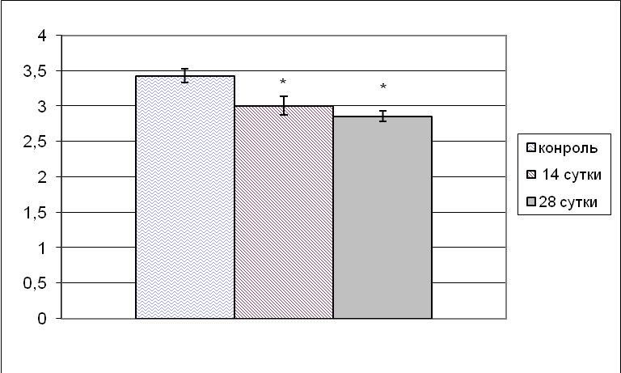
* – Р≤0.05 – in comparison to the control
Control
The 14-th day
The 28-th day

Fig. 2. Contents of Copper in the rats liver in administration of ethanol in the conditions of the chronic alcohol intoxication development on the 14 and 28 days after ethanol administration.

An expressed decrease of Copper contents in liver by 83% in 28 days in the long-term administration of alcohol has been detected. The obtained results may be explained by the fact that chronic ethanol influence leads to inflammation, constant hepatocyte damage [5, 14], leading to discharge of substances, containing Copper, to blood [11]. Copper deficit leads to serious disorders of an organism vital activity: inhibits protein synthesis processes, causes disorders of the blood-forming organs functions and reproduction, phagocytic activity of the blood and immunological values. The microelement is known to take part in nitrogen exchange, comprises the nitrate-reductase complex, participate in the processes, supplying tissues with oxygen, accordingly its deficit leads to disorders of such processes [6]. Besides, functions of the copper-containing enzymes may be affected, involved in the oxidizing and reducing reactions, neurotransmitter synthesis, peptide hormone activation [14].
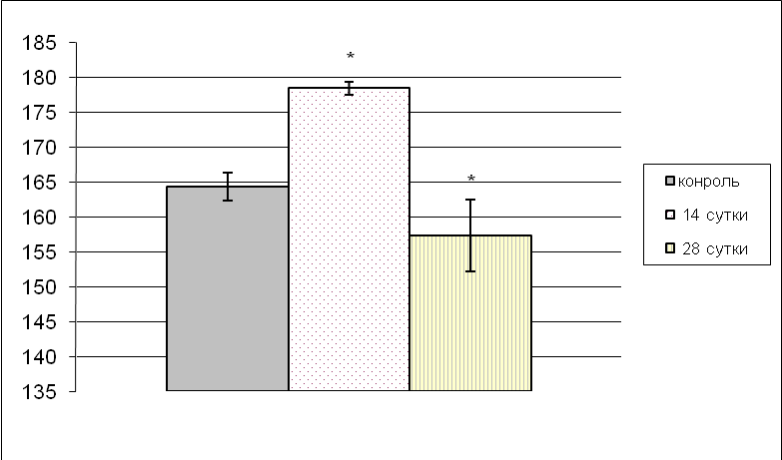
* – Р ≤ 0.05 – in comparison with the control
Control
The 14-th day
The 28-th day
Fig. 3. Magnesium content in the rats liver in the conditions of the chronic alcohol intoxication development on the 14, 28 days after ethanol administration.

We have shown an increase of Magnesium contents in liver on the 14-th day by 109% in comparison with the control. It may evidence of activation of the adaptation mechanisms of an organism, developing in response to ethanol action. The decrease of the studied parameter on the 28 day by 95% in comparison with the control values may be related to the fact that substantial disorders of Magnesium cation contents may cause serious changes inside the cell mechanisms.
In the conditions of Magnesium deficit there is destabilization of the transport-non-coding RNA (a number of RNA dysfunctional molecules is increased), accompanied by a decrease and inhibition of the cell protein structure synthesis rate with a relative prevalence of apoptosis processes, sensitivity to the oxidative stress is increased (increase of the tissues sensitivity to oxidation). All the above mentioned facts may be reasons for the liver damage development in the alcohol intoxication [14, 20, 8].
Conclusion
Disorder of Zinc, Magnesium and Copper contents in the rats liver tissue in the conditions of chronic alcohol intoxication has been detected. The changes we detected may induce metabolic deviations related to changes of functional activity of the intramolecular system components, which realization depends on the contents of the studies cations.

List of references:
- Derecha L. М. Alcohol and its action on an organism: literature review / [Derecha L. М.] // Herald of Kharkov National University. – 2007.– Edition 6. – № 788. – P. 7—16.
- Derecha L. М. Condition of biological membranes and contents of macro- and microelements in a human and animal organism influenced by ethanol. Autoabstract of the dissertation. … Candidate of Biological Sciences (03.00.04 – biochemistry). – Kh., 2006. – 20 p.
- Zadorozhnyaya V. Yu., Eschenko Yu. V., Bovt V. D., Eschenko V. А., Grigorova N. V. //Contents of Zinc and Magnesium in cells and extracellular space as a result of alcoholization.-The Higher Zaporizhia National University .- 2010.- № 2.- P. 63—70.
- Koterov А. N. Influence of zinc-metallothionein on peroxidation of lipids in blood plasma and rats liver in the acute alcohol intoxication / [Koterov А. N., Shilina n. М.] // Ukrainian Journal of Biochemistry. – 1995. – V. 67, № 4. – P. 80—87.
- Kudrin А. V., Zhavoronkov А. А. The role of microelements and Calcium in the apoptosis regulation // Modern biology progress. – 1998. – V. 118, № 5. – P. 623—629.
- Microelements in medicine. – 2001. – V. 2, - Ed. 2. – P. 46—47.
- Moiseev V. S., Ogurtsov P. P. Alcoholic disease: pathogenetic, diagnostic and clinical aspects // Therapeutic Archive. – 1997. – № 12. – P. 5—12.
- Rychkova Т. I. The physiological role of Magnesium, the meaning of its deficit in the connective tissue dysplasia in children // Pediatrics.-2011.-Volume 90.-№ 2- P. 114—120.
- Skalnyi А. V. Influence of Zinc on activity of ethanol-oxidizing enzymes in alcoholized rat offsprings / [Skalnyi А. V., Kampov-Polevoy А. B., Voronin А. Е.] // Microelements in medicine. – V. 2. - № 2. – P. 21—23.
- Skalnyi А. V. Zinc dysbalance in alcoholism and ways of its correction. // Microelements in the USSR. - 1991. Ed. 32 – P. 82—89.
- Skalnyi А. V., Investigation of the influence of the chronic alcohol intoxication on Zinc, Copper and Lithium exchange in an organism // Dissertation ... Candidate of Medical Sciences. - М., 1990. – 137 p.
- Torshin I. Yu., Gromova О. А., Grishina Т. R., Rudakov К. V. Hierarchy of Zinc and Iron interaction: physiological, molecular and clinical aspects // Complicated case.-2010.- № 3.-P. 100—101.
- Khalilov М. Kh., Zakikhordzhaev Sh. Ya. Characteristics of some pathochemical deviations in blood, liver and brain tissues in experimental alcohol intoxication // Issues of the alcoholism clinic: Collection of scientific papers, Tashkent, 1983. – P. 38—41.
- Khvorostinka V. N., Zhuravleva L. V., Lakhno О. V., Tsivenko О. I.//The pathogenetic role of micro- and macroelements of blood serum in patients with chronic hepatitis and liver cirrhosis // Modern Gastroenterology. – 2009. - V. 46. - № 2. - P. 119—124.
- Chmilenko F. А., Saevich О. V. Peculiarities of soft tissue sample preparation in determining metals //Methods and objects of chemical analysis.- 2010.- V. 5. - № 1. - P. 14—18.
- Aulda D. S. and. Bergmanb T //The role of zinc for alcohol dehydrogenase structureand function.- 2008.-Cell. Mol. Life Sci. Vol.-65.- P. 3961—3970.
- Dario Raheliс, Milan Kujundzic, Zeljko Romic, Kristina Brkic and Mladen Petrovecki //Serum Concentration of Zinc, Copper, Manganese and Magnesium in Patients with Liver Cirrhosis.-2006. - Vol.-30.- № 3.- P. 523—52.
- Kushnir E. A. Polyoxidonium in the immunological correction of alcoholic motivation / [Kushnir E. A., Lovat M. L., Obukhova M. F.] // Immunology. – 2004. – V. 2. – Р. 87.
- Mi L. J., Mak K. M., Lieber C. S. Attenuation of alcoholinduced apoptosis of hepatocytes in rat livers by polyenylphosphatidylcholine (PPC) // Alcohol Clin. Exp. Res. – 2000. – Vol.24 (2). – Р. 207—212.
- Subir Kumar Das Sukhes Mukherjee D. M. VasudevanInd//Effects of Long Term Ethanol Consumption on Cell Death in Liver.- Clin Biochem.- 2011.-V. 26. -№ 13. – P. 84—87.
- Tabakoff B., Hoffman P. L. Biochemical pharmacology of alcohol // Psychopharmacology: The third generation of progress / Ed. by H.Y.Meltzer. – N.Y.: Raven Press.-1987. – P. 1521—1526.
- Zhanxiang Zhou and Wei ZhongZinc and Hepatocyte Nuclear Factor-4αin Alcohol-Induced Intestinal Barrier Dysfunction //Journal of Epithelial Biology and Pharmacology. - 2012.-Vol 5.- P. 19—27.

