Manuscript copyright

Berezkina Elena Sergeevna

The effect of preconceptional alcohol intoxication in female rats on the containment of macro- and microelements in different organs of the progenies.

14.01.27 – Narcology

Autoabstract
Of the Ph.D. (Biology) thesis

Moscow – 2010
The reported investigation has been performed in the Institute of Bioelementology, a subunit of the State Educational Institution of Higher Professional Education «The Orenburg State University» (rector – D.Sc. (Economics), professor Kovalevskiy V.P.)

Research advisor:
Doctor of Medical Science, Skalnyi Anatoliy Viktorovich
professor

Official opponents:
Doctor of Biological Sciences Proskuryakova Tatyana Vasilievna

Doctor of Biological Sciences, Karganov Mihail Yurievich
professor

Leading organization: Peoples’ Friendship University of Russia

The Ph.D. defense is going to be held on « _____ » _________________ 2010 at ________ (time) during the Dissertation Council board (Ph.D. and M.D.) (session number 208.051.01, Federal State Institution “National Scientific Center”, a subunit of the Russian Healthcare Supervision Agency). The Council board address: 119002 Moscow, Malyi Mogiltsevskiy lane, facility 3.

The thesis materials are available in the Scientific Library of the Federal State Institution “National Scientific Center”, a subunit of the Russian Healthcare Supervision Agency, using the following address: 119002 Moscow, Malyi Mogiltsevskiy lane, facility 3.

The autoabstract has been sent on « _____ » _________________ 2010.

Academic secretary
Ph.D. (Biology) Lvova O.F.
The scientific investigation overall characteristics

The timeliness of the investigation. In recent years Russian population demonstrates a significantly higher level of women with abusive alcohol consumption (Koshkina Е.А. Kirzhanova V.V., 2008; Altshooler V.B., Mokhnachev С.О., 2008), including the abusive drinking behavior for the pregnancy period. Amongst all the consequences of the alcohol’s threat to the fetus the leading role belongs to the brain impairments detectable on the different stages of the postnatal period due to different cognitive disorders, including attention disorders, difficulties in acquiring information, mnemonic disorders and others. (Arzumanov Yu.L., 2001; Altshooler V.B., Kravchenko S.L., 2008).
A major alarming concern is that most people think that consuming low-alcohol beverages or consuming low amount of alcohol before getting pregnant is safe for the progeny. Such a fallacy is especially wide-spread among the teenagers and youngsters.
It is well-known that alcohol consumption leads to metabolic and functional disorders in almost all the systems of the organism (Ivanets N.N., 2008). The reported investigations sometimes show the influence of the alcohol intoxication on the isolated macro- and microelements within the organisms of the mother and children (Skalnyi А.V., 1990; Rosenbaum J.S., Zidenberg-Cherr S., Keen C.L. 1991; Keiver K. et al., 1997; Kohgo Y. et al., 2005; Cylwik B., Chrostek L., Szmitkowski M., 2008, etc.). However, these data are quite few and fragmental. The actual problem that is still unsolved is - are there any changes in mineral metabolism of a progeny in mothers that fully stopped consuming alcohol before deciding to have a baby?
The human organism contains a full spectrum of chemical elements (ChE.), and each one can be found in the surrounding environment. Some of them may be present in the organism for a short period of time (without taking part in the metabolic processes), but most of ChE are involved in different metabolic and physiologic functions. The activity spectrum of the macro- and microelements is quite wide and mostly involves multiple interactions with different enzymes, hormones, neuromediators, vitamins, peptides and other biologically active substances (Avtsyn А.P. et al, 1991; Tutelyan V.А. et al., 2002; Skalnaya M.G., Notova S.V., 2004; Oberlis D. et al., 2008). According to the opinion of several researchers, an impairment of the mineral metabolism could be one of the triggering mechanisms in alcohol intoxication (Skalnyi А.V., 1990; Novoselov Ya.B., 2001; Panchenko L.F. et al., 2004; Keen C.L. et al., 1997 etc.).
Several research reports show the effectiveness of pre-natal micronutrients status disorders prevention in infants, especially in case of pathologic processes within the mother’s organism (Zhuravleva E.A. et al., 2007; Molloy A.M. et al., 2008; Zeisel S.H., 2008 etc.). In particular – USA prevention program protocols for mothers that abuse alcohol, includes undergoing a correction course with folic acid and choline formulations intake and, which is important, with zinc-containing formulations intake (Keen C.L. et al., 2010). However, there are no available results of the investigational experiments concerning the antenatal metabolic correction treatment (macro- and microelements) in mature progenies of females that consumed alcohol before getting pregnant.
The current scientific data states that zinc formulations can be used to provide corrective treatment, as zinc deficiency notably takes place during alcohol intoxications, as well as in cases of embryo- and fetopathy due to alcohol abuse in mothers (during the pregnancy) (Semenov А.S., Skalnyi А.V., 2009; Maret W., Sandstead H.H., 2008). In addition to that, zinc deficiency is very often found in pregnant women and breast-feeding mothers (even without previous alcohol abuse), as well as it is often found in children (Oberleas D., 1996, Yasui M. et al., 1997, DiSilvestro R.A., 2005; Shah D., Sachdev H.P., 2006; Hess S.Y., King J.C., 2009 etc.), especially the ones with depressed immune system activity and various disorders of the central nervous system (Prasad A.S., 1983, 2009).
All the abovementioned information defines the actuality of the present experimental investigation.

Objective: To assess the effect of the alcohol intoxication in female rats before pregnancy by measuring the macro- and microelements concentrations within different structures of the brain and in different organs of the mature progenies.

Investigation goals:

- To define the concentration of the macro- and microelements in the organs and brain tissue in mature progenies of the female rats after alcohol exposure before mating with intact (non-alcoholic) males.
- To assess the effectiveness of zinc sulfate administration in rat females during different periods (mating, pregnancy, breast-feeding) by measuring the macro- and microelements concentration in brain tissue (different brain structures) samples obtained from the rat mature progenies.
- To perform the significance assessment of the data concerning chemical elements proportions within the investigated brain structures and organs of the mature progenies, including the groups of female rats that were taking zinc sulfate.

Scientific novelty

This experiment is the first to obtain data concerning the concentrations of macro-elements (calcium (Ca), phosphorus (Р), potassium (K), sodium (Na), magnesium (Mg)) and microelements (iron (Fe), zinc (Zn), copper (Cu) and manganese (Mn)) in tissue samples obtained from organs and different brain structures of mature rat progenies (female rats were alcoholized before pregnancy) with further comparative analysis against a group of intact female rats).
For the first time it has been stated that alcohol administration to female rats (before mating with intact males) results in the disproportions in ChE concentrations within different organs and tissues, which leads to elevated levels of Ca, K and Na in the hepatic tissues, Р – in kidney tissues and К- in the cardiac muscle. The brain tissue samples (different segments of the brain) presented decreased levels of Na, Mg, К, Fe, Zn (brain cortex), Ca, P, Fe, Mn (white substance), Mn (hippocampus). The cerebellum decreased level of Mn is followed by an elevated concentration of Zn.
For the first time it has been reported that after an alcohol exposure in rat females (before mating) the most significant deviations of macro- and microelements concentrations (in mature progenies) take place in the hepatic tissue, the brain cortex and the brain white matter.
For the first time it has been shown that antenatal and postnatal administration of zinc sulfate (after an alcohol exposure) effectively corrects the alcohol impact on mother’s organism (alcohol exposure before pregnancy). A positive therapeutic effect of zinc sulfate administration is expressed in normalizing the Mn concentrations in the cerebellum and hippocampus tissues, K, Na, Mg, Fe, Zn – in the brain cortex samples, Ca, P, Fe, Mn – in the brain white matter samples (in mature rat progenies), thus, the observed effect can successfully prevent the development of pathological deviations, caused by the deficiency of the abovementioned chemical elements.

Propositions to be defended

- Alcohol consumption cancellation (even after a short period of exposure) in rat females before mating with intact males, as well as for the pregnancy period and during breast-feeding, does not prevent the development of macro- and microelements disproportional deviations within the organs and brain structures (in mature progeny).
- The most sensitive parameters (concerning the effect of the alcohol exposure in rat females) are the concentrations of chemical elements within the hepatic tissues, the brain cortex and white matter of the mature progenies.
- Disproportional deviations of the chemical elements concentrations (Diselementosis) within the brain structures of the mature rat progenies (in females that were exposed to alcohol before mating with intact males), are considerably correctable with the use of the zinc sulfate water solution (when administered in to the rat females during pregnancy and lactation).
- The alcohol exposure (in rat females - before mating with intact males) significantly affects the absolute concentrations of macro- and microelements within the organs and brain tissue samples of the rat mature progenies.
- The chemical elements proportions within the organs and brain structures of the mature rat progenies are less prone to deviation, then the absolute values (chemical elements concentrations), including the groups of rats that were given zinc sulfate as a correction treatment.

Practical significance

The results of the performed investigation can be used for educational purposes in medical and pharmaceutical higher educational institutions, as well as in the biology and chemistry teacher training departments (for providing information about the pre-natal alcohol consumption’s great influence on the health conditions of children). The detected cases of elemental disproportions within the organs and brain structures of the rat mature progenies (alcoholisation before mating with intact males) show signs of the development of the metabolism impairments and physiological disturbances (that take place in the postnatal period), which serve as an evidence of the strict necessity for seeking ways to correct (ante- or postnatally) the negative consequences of the alcohol intoxication in female rats before they got pregnant. The perspectives of such a therapeutic approach are still to be researched.
Zinc sulfate and other zinc formulations may be considered as a treatment medication for correcting the negative consequences (found in internal organs and brain structures of the mature progenies) of the short-time periods of alcohol intoxication in rat females. The administration of the zinc-containing formulations during pregnancy and breast-feeding with episodes of alcohol exposure to the rat females before mating enhances the effectiveness of the compensatory and adaptive reactions that provide the intactness of the structural homeostasis in the central nervous system and the whole organism at a molecular level.

Thesis approbation

The materials of the research work were reported during the VIII ISTERH conference (The International Society for Trace Element Research in Humans) «Trace Elements in Diet, Nutrition and Health: Essentiality and Toxicity» (Crete, Greece, October, 2007); during the All-Russian Scientific Research Conference with international cooperative participation «Physiologic and Hygienic problems of the human ecology» (Belgorod, May 2007); during the 1st Russian national Narcology Congress (Moscow, November, 2009); the materials of the research work were reported to task group of the Federal State Institution “National Scientific Narcology Center”, (Moscow, April, 2010); the materials of the research work were reported during the 4th International Symposium on Trace Elements and Minerals in Medicine and Biology) (Saint Petersburg, June 2010).

The results of the research work –publications

The results of the research work were issued in 10 separate articles, among which 3 are published in journals licensed by the State Commission for Academic Degrees and Titles (Ministry of Education and Science of the Russian Federation). The results of the research work were mentioned in 2 chapters of the multi-author book.

Implementation of the research results

The results of the research work were implemented into the investigational activities of the Institute of Bioelementology, a subunit of the State Eductational Institution «Orenburg State University»; the implementation has also been performed in the Federal State Scientific Institution «The Institute of Toxicology», a subunit of the Federal Bio-Medical Agency of the Russian Federation; the results of the research work were implemented into the educational process (the Department of Nutriciology and Bioelementology of the State Educational Institution «Orenburg State University», the Department of Normal Physiology of the Peoples’ Friendship University of Russia. The results of the researched work provided a rationalization of adding the zinc asparaginate to the specially designed “Universitetskiy” drinking product (–manufactured by “Zhivaya voda” Ltd. (Orenburg).

The structure and the extent of the thesis work

The thesis work includes 140 pages of typed text, including the following chapters: introduction, background, materials and methods (that were used for the research work), results summary and discussions of the obtained data, conclusions, applicational recommendations and references list. The illustrative material includes 18 figures and 16 tables. The reference list contains 193 bibliographic sources (72- national and 121 foreign).

Research work: Contents

Investigative techniques

The research work has been performed on 227 random breed white rats: 32 females, 10 males, 185 – progenies.
The experimental animals were held in the bioclinics of the Institute of Bioelementology (a subunit of the State Eductational Institution «Orenburg State University» (director, M.D., professor А.V. Skalnyi) with the use of the usual light status (temperature +20-24°С). The basic food source for the experimental animals was – № 1cubed feed.
At the beginning of the experiment all the animals (32 rat females) were divided into 3 groups. The 1st group received 15% ethanol solution as the only source of liquid during 20 days (average values - every rat female was exposed to 13.3 g/kg of ethanol daily). On the day before mating with intact males the rat females of the 1st group were give usual water. The 2nd group of experimental animals received ethanol just like the 1st group, and on the day before mating with intact males the rat females were consuming a 0.003% water solution of zinc sulfate (average values: every animal received 0.05-0.07 µg/kg of Zn daily). The rat females of the 2nd group were receiving a water solution of Zn sulfate for the next 45 days after mating (i.e. for the whole bearing and breast-feeding period). The 3rd group of experimental animals received only water for the whole experimental period.
The progenies were received in 26 out of 32 female rats. The total amount of progenies was 185 animals. In the first group of alcoholised female rats the progenies were received in 9 females out of 11 (total animal count -54 females and males). In the second group of female rats that received alcohol before mating (after getting pregnant and during the breast-feeding period – zinc sulfate water solution) the progenies were received in 10 out of 13 females (total animal count - 62 females and males). In the control group the progenies were received in 7 out of 8 females (total animal count – 69 females and males), 1 rat female in the control group did nott get pregnant.
Out the total amount of progenies 60 animals (males) were chosen for participating in the second phase of the experiment: 20 animals in each group.
As can be seen from above, the first group of progenies of the rat females that were receiving ethanol (the day before coupling – common water) (herein – group «А»), 2nd group consisted of progenies of the rat females that were receiving ethanol (but on the day before coupling – water solution of zinc sulfate) (herein – group «А+Zn»). The animals of the control group (3rd group, herein – group «К») were the progenies of the intact rat females (receiving only water, grown up in the same conditions as treatment groups).
Upon reaching the maturity age (90 days old) all the Phase 2 animals were decapitated according to the requirements of the Animal Biology Research Ethics Committee of the Russian Academy of Sciences, as well as according to the requirements stated by the Guidelines for Ethical Treatment of Animals in Applied Animal Behavior and Welfare Research (Animal Research Act, 1985).
After the decapitation samples were obtained from the following organs, tissues and brain structures for performing further assessment of 9 ChE concentrations (K, Na, Ca, Mg, P, Fe, Zn, Cu, Mn): liver, kidneys, heart muscle, skin, gonads, brain cortex an white matter, cerebellum and hippocampus samples. The separated organs were dissected with the removal of the blood residue. After these procedures the weight of the organs was measured, then the organs were stored in the hermetically sealed laboratory containers. The samples were stored in the deep-freeze chamber (-20°С).
The elemental containments of the tissue samples was assessed with use of mass-spectrometry and inductively-coupled argon plasma atomic emission spectrometry (devices - Optima 2000 (Perkin Elmer) and ICAP-9000 (Thermo Jarrell Ash, USA)) according to Methodological Guidelines 4.1.1482-03 and 4.1.1483-03, approved by the Ministry of Healthcare and Social Development of the Russian Federation.
For elemental containment assessment the most typical spectral lines were used (total suitable characteristics set). The most important of the characteristics were the intensity, absence of spectral folding, signal/noise ratio, detection limit, background equivalent concentration. The analytical signals were processed with the use of spectrophotometer software options - applying calibration dependencies, calculated by the least-square method, acquiring and correcting the background level, and, if necessary, calculating the elemental interaction (for the assessed elements). The final displayed result corresponds to arithmetical mean value obtained using several simultaneous measurements for the assessed element.
Statistical processing of the obtained data was performed with the use of Microsoft Excel XP software (Micosoft Corp., USA) and Statistica 6.0 Software (StatSoft Inc., USA). The validity of the revealed differences was tested using the Mann-Whitney U-test. At the significance level of р<0.05 the differences were considered significant, and if the р falls in the range 0.05<р<0.1, the differences were considered as tendencies.

Experiment results, discussions

The obtained results are shown as figures, in which the concentrations of the chemical elements (ChE) of the control group (K group) are considered to be 100% (green horizontal line), and the height of every column depicts a deviation of the element concentration value in the А-group (comparing to the ChE concentration in the К-group, percentage).
The results of the experiment show that within the hepatic tissue of the A-group rats a significant elevation of Ca, K and Na levels (macroelements) was detected, as well as an increasing tendency for the concentrations of Mg, Р, Cu and Mn; Zinc concentration – decreasing tendency (Fig.1). These data show that in the given organ the levels of most ChE are elevated, which can be a sign of metabolism intensity within the organ and, thus, indicating the increase of the organ’s functional load (Skalnyi А.V., 2000).
Literature data show that chronic and acute alcohol abuse leads to a decrease of Ca and Mg liver concentrations (rat liver) with no observed deviations of Na and K values (Dhawan D. et al., 2005; Cefaratti C. et al., 2003, 2005). The results of our research work show that Ca level (hepatic tissues of the mature progenies) is significantly higher comparing to the K-group. А.V. Skalnyi et al. (2001) detected a decrease of Ca values in the hepatic tissues of the progenies received form female rats that were exposed to alcohol before getting pregnant and during bearing. However, unlike the results obtained from the present research work, the abovementioned authors were evaluating the Ca values with the use of hepatic tissue supernatant. It is possible that the Ca concentration decrease detected by these authors was a result of more intensive alcohol exposure.
Besides, the increasing tendencies for Mn and Fe concentrations were noted (for hepatic tissues), which enable to consider the development of metabolical and functional disturbances of that organ (in progenies of the female rats that were exposed to alcohol before mating with intact males).
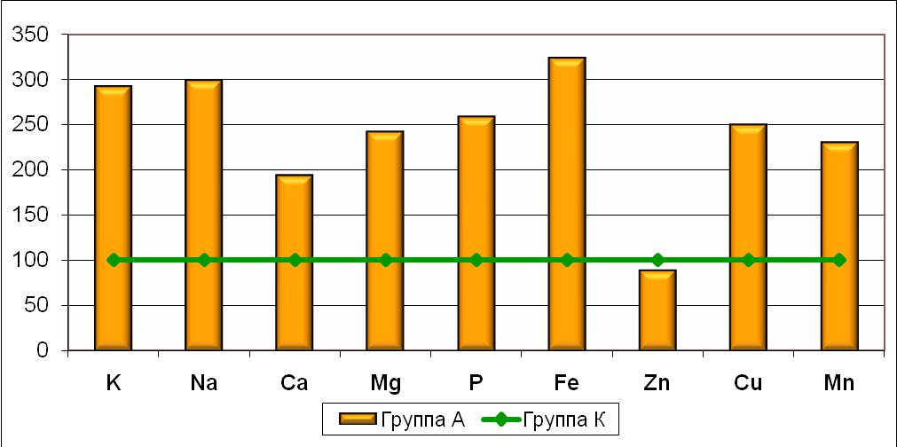
Group A
Group K
*
*
*
Figure1. Concentrations of macro- (Ca, Mg, P, K, Na) and microelements (Fe, Zn, Cu, Mn) in the hepatic tissues of mature progenies of the female rats that were exposed to alcohol before mating with intact males (%). note: * stands for р < 0,05 – significance level (comparing to К-group).
It is known that Mn (specific concentrations) can act toxically, the mechanism of that toxic activity is related to the impairments of protein synthesis within the hepatic tissue, as well as it is related to the deviations of amino-acid content of the hepatic proteins (Rutkovskiy G.V. et al., 1998; Zabrodskiy P.F., 1998). The elevated Fe values in the organism (including liver) lead to stimulating the lipid peroxygenation and cellular membranes stability impairment.
A special attention must be given to a decreasing tendency for zinc concentrations (within the hepatic tissues, group А) with simultaneous elevation of the copper concentration (copper is the functional antagonist of zinc). Zn deficiency in the hepatic tissues leads to a decreasing activity of the immune system (non-specific factors) and, thus, it leads to a higher susceptibility for different infectious diseases (Avtsyn А.P. et al., 1991). The multidirectional deviations of the given ChE concentrations could act as an indicator of metabolical deviations after alcohol exposure (Skalnyi А.V., 1990).
In the kidney tissues of the А-group rats a statistically significant elevation was observed only for Р, the concentration of which is 1.4-fold higher when comparing to К-group animals (Fig.2).
The kidneys are the leading organs in regulating phosphorus balance (which is presented in the organism as different phosphates). Alcohol exposure can cause hyperphosphatemia, as well as hypophosphatemia. The development of the hyperphosphatemia can be induced by an increase in extracellulation of phosphates in cases of kidney functional depression (Oberlis D. et al., 2008).

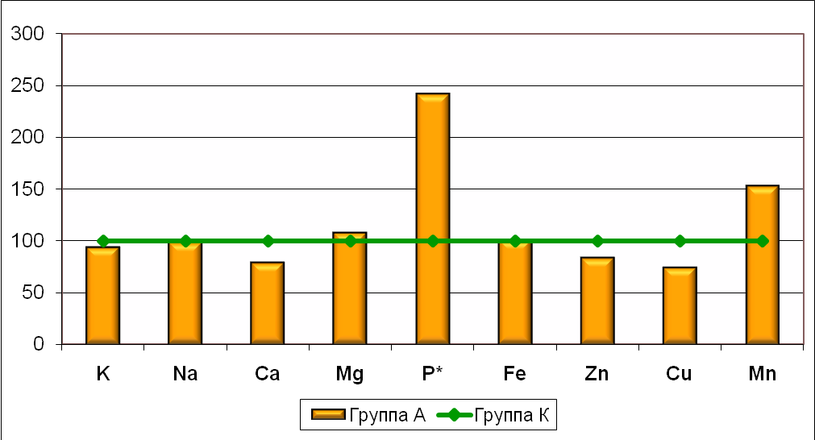
Group K
Group A
*
Figure 2. Concentrations of macro- (Ca, Mg, P, K, Na) and microelements (Fe, Zn, Cu, Mn) in the kidney tissues of mature progenies of the female rats that were exposed to alcohol before mating with intact males (%). note: * stands for р < 0,05 – significance level (comparing to К-group).
Elevated levels of phosphorus in the kidney tissues enable to considering that short-time exposure to alcohol in rat females before mating with intact males may induce the development of metabolical nephropathy in mature progenies.
A significant elevation of К levels was noted within the cardiac muscle of the group A rats (61% higher then group K rats) with a decreasing tendency for Mg, Na and P (Fig. 3), which confirms the literature review data (the deviations of К levels within the organism are often followed by disproportions of Mg, Na, Ca and Р metabolism).
One of the basic potassium functions in the human body is to decrease the heart rate. However, significant elevation of potassium concentration may lead to an impairment of the contractile function of the cardiac muscle. Additionally the contractility of the cardiac muscle is significantly influenced by elevated levels of Mg in the myocardium (Gorodetskiy V.V., Talibov О.B., 2003). The detected elevation of К and Mg within the cardiac muscle does not exclude the risk of heart abnormalities in mature progenies of the female rats that were exposed to alcohol before mating with intact males. The potassium level in the biological substrates is often elevated in cases of kidney function impairment, adrenal glands impairment and other pathological processes (Barashkov G.К., 2007).
The elemental assessment of the seminal gland samples of Group A rat showed the decreasing tendency for P concentration (comparing to Group K rats), skin samples showed increasing tendency for Mg.

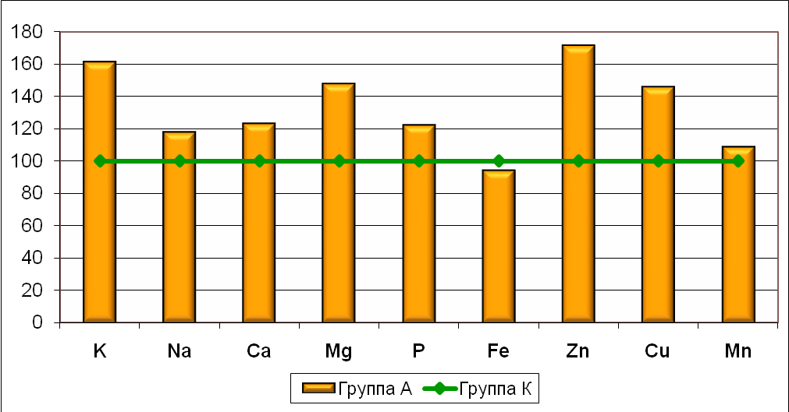
Group K
Group A
*
Figure 3. Concentrations of macro- (Ca, Mg, P, K, Na) and microelements (Fe, Zn, Cu, Mn) in the cardiac muscle samples of mature progenies of the female rats that were exposed to alcohol before mating with intact males (%). note: * stands for р < 0,05 – significance level (comparing to К-group).

That means - alcohol exposure cancellation (after a short-time intoxication) in female rats before mating with intact males affects the ChE levels mostly in hepatic tissues, cardiac muscle and kidney tissues (mature progenies), but that does not exclude the probability of developing metabolical and functional disturbances of the given organs. The absence of statistically significant deviations in elementary status of seminary glands and skin tissue samples (mature progenies of the female rats that were exposed to alcohol before mating with intact males) presumably indicates the decreased risk degree for developing metabolical and functional disturbances within the reproductive system and skin of the mature progenies. This is an important indicator of the changes that take place in the progeny’s organisms; moreover, the obtained data confirm that the established opinion concerning the relative harmlessness of the short-time alcohol exposure before getting pregnant is a fallacy.
It is important to note that ethanol is just one of the many factors that are able to deviate the metabolism parameters of macro- and microelements upon exposure. The disproportion of the ChE values serves as a predictor of the deviated elemental metabolism concerning multiple levels of impairment. The examples of other pathogenic factors (capable of causing elemental disproportions) are chronic cadmium intoxications (Zalavina S.V., 2008; Kiyaeva Е.V., 2009; Semenov А.S., Skalnyi А.V., 2009), lead intoxications (Skalnyi А.V. et al., 1997, Skalnyi А.V., Bykov А.Т., Limin B.V., 2002 etc.), vibration exposure (Zalavina S.V., Skalnyi А.V., Кузьменко Kuzmenko D.B., 2008) and many others. The results of the research work by S.V. Zalavina et al. (2009) show that it is possible to prevent the development of the toxic effects of the chronic cadmium intoxication in the progenies of rat females by administering zinc formulations to rat females during the bearing period.
Our research work was directed to perform the assessment of the bioelementary status of the brain structures samples of progenies received form the female rats (the females were exposed to alcohol intoxication before mating with intact males). According to the data shown in Fig. 4, the A-group animals presented a statistically significant decrease of К, Na, Mg, Fe and Zn levels in brain cortex tissue samples (comparing to the animals of the control K-group).

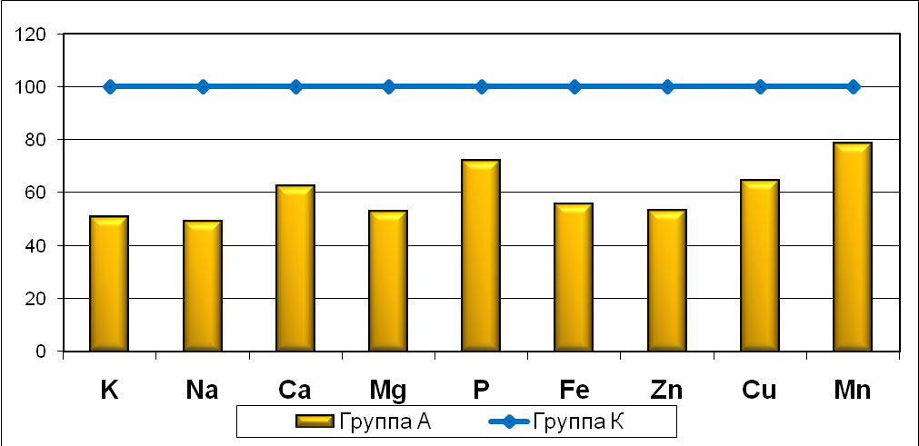
Group K
Group A
*
*
*
*
*
Fig. 4. Concentrations of macro- (Ca, Mg, P, K, Na) and microelements (Fe, Zn, Cu, Mn) in the brain cortex samples of mature progenies of the female rats that were exposed to alcohol before mating with intact males (%). note: * stands for р < 0,05 – significance level (comparing to К-group).
A decrease in potassium and sodium levels among the group A animals (in the brain cortex tissue samples) surely affects the transmembraneous К⁺ and Na⁺ passage (with the activation of voltage-operated К⁺- and Na⁺- channels), as well as it affects the performance characteristics of the К⁺,Na⁺-ATP-pump, consequently affecting the action potential generating and impulse conduction. It is necessary to note that the functional characteristics of the К⁺, Na⁺-ATP-pump significantly depend on Mg level (which is decreased in the brain cortex tissue samples of the group A rats). One of the major roles of Mg in the organism is related to depressing the irritability of the neurons, which enables to consider that Mg deficiency evidently increases the neuronal irritability. Prolonged Mg deficiency provokes the development of such disturbances, as hyperexcitability, convulsions, mnemonic impairments, etc. (Gunter T., 1990). This corresponds to the literature review data concerning the hyperexcitability and other central nervous system disturbances in progenies of the females, exposed to alcohol intoxication (Skalnyi А.V., 1990; Jones K.L., 1975; Jones K.L., Smith D.W., 1975; Abel E.L., 2009 etc.).
The data concerning the brain white matter ChE concentrations are the following: group A rats – statistically significant decrease of Са, Р, Fe and Mn levels (comparing to the K-group) and a decrease tendency for К concentration (Fig.5).
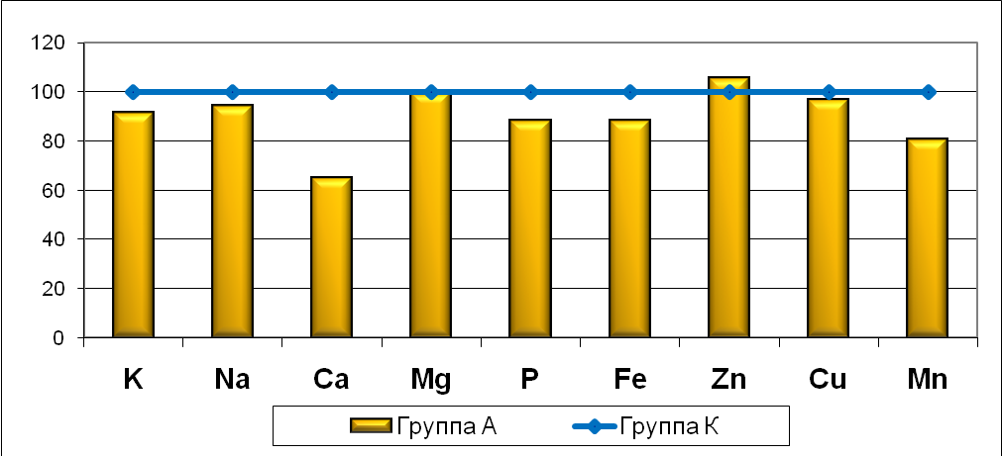
Group K
Group A
*
*
*
*
Figure 5. Concentrations of macro- (Ca, Mg, P, K, Na) and microelements (Fe, Zn, Cu, Mn) in the brain white matter samples of mature progenies of the female rats that were exposed to alcohol before mating with intact males (%). note: * stands for р < 0,05 – significance level (comparing to К-group).
The assessment of the cerebellum tissue samples showed the following data: statistically significant decrease in Mn concentration with an elevation of Zn concentration (рис. 6), while the hippocampus tissue samples showed decreased Manganese values (statistically significant) with a decreasing tendency for Iron (Fig. 7).
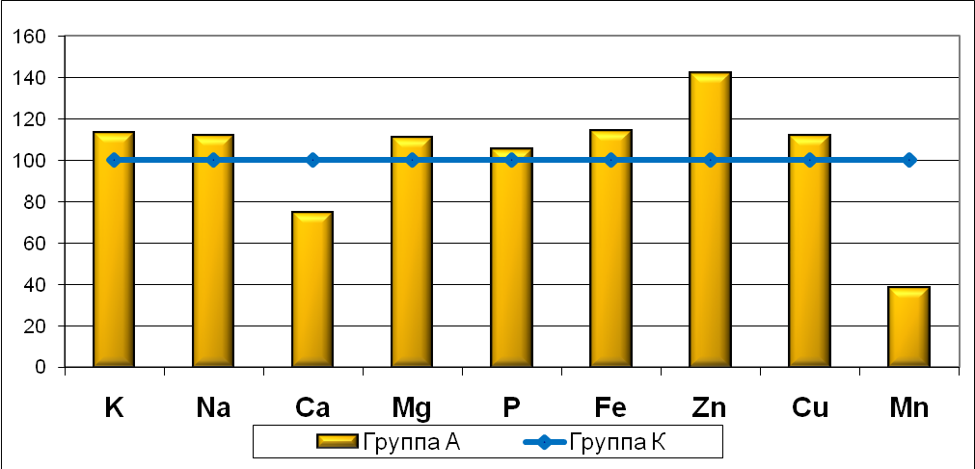
Group K
Group A
*
*
Figure 6. Concentrations of macro- (Ca, Mg, P, K, Na) and microelements (Fe, Zn, Cu, Mn) in the cerebellum tissue samples of mature progenies of the female rats that were exposed to alcohol before mating with intact males (%). note: * stands for р < 0,05 – significance level (comparing to К-group).

The brain cortex levels of zinc in mature progenies of the rat females, preconceptionally exposed to alcohol, were 47% lower, while the cerebellum values were 42% higher. The zinc homeostasis impairment and zinc disproportions in the given central nervous system organs are considered to be caused by different metabolic disturbances, for examples, the impairment of metallothionein III metabolism (Taubeneck M.W. et al., 1994) and the pathologic processes associated to that impairment (within the brain tissues), including the inflammatory processes (Mocchegiani E. et al., 2007). According to the physiologic role of zinc in the organism, in particular, its activating potential for cellular proliferation and proteins synthesis (Prasad A.S., 1983; Sandstead H.H., 1986), А.V. Skalnyi (1990) considered that the lowered concentrations of this element within the brain cortex is one of the mechanisms of the higher nervous function impairments: mnemonic disorders, cognitive disorders and kinetic activity deviations.

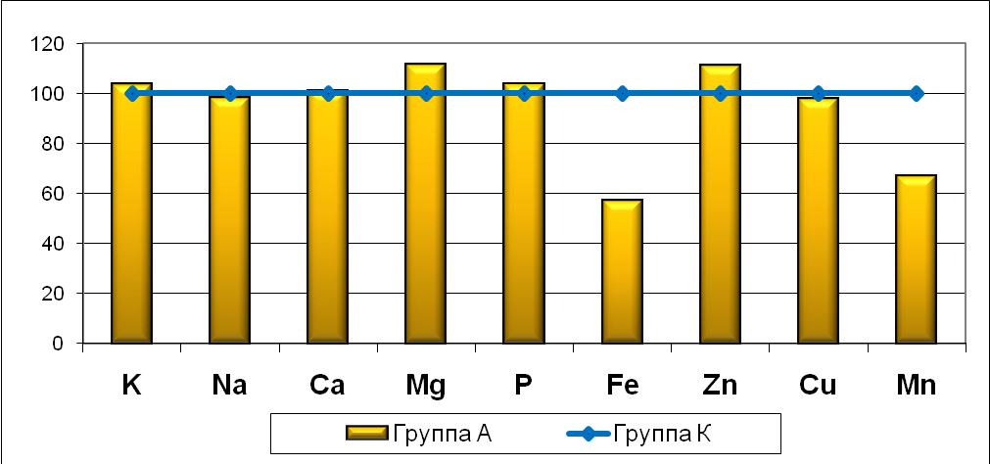
Group K
Group A
*
Figure 7. Concentrations of macro- (Ca, Mg, P, K, Na) and microelements (Fe, Zn, Cu, Mn) in the hippocampus tissue samples of mature progenies of the female rats that were exposed to alcohol before mating with intact males (%). note: * stands for р < 0,05 – significance level (comparing to К-group).

On the other hand, S.L. Sensi et al. (2003) suppose that intracellular accumulation of Zn ions leads to damage of neurocytes. At the same time the neurocytes impairment could be caused by the Mn deficiency in the given brain structure, followed by an increase of the free radical-mediated oxidation and further cellular membranes destabilization (Gluschenko N.N. et al., 1996; Aschner M., 2007).
Special attention should be given to a decrease of Manganese levels in the brain white matter, the cerebellum and the hippocampus tissue samples in the experimental progenies (the most notable decrease was found in the cerebellum tissue samples). One of the functions of Manganese on the organism is related to its role in the neuromediators synthesis and metabolism (Erikson K.M., 2003). The Manganese prevents the progression of the free radicals oxidative stress reactions (for example, in conjunction with superoxide dismutase), thus, providing a better stability of the cellular membranes structure (Aschner M., 2007).
The Iron deficiency impacts the nerve fibers myelinisation (Breymann C. et al., 1995). Demyelinisation can be a result of many diseases, it leads to a much slower signal transferring and to a spontaneous irritation of the nearby nervous fibers. Taking that into account enables to consider that the revealed Iron levels decrease in the brain cortex, in the white matter and in the hippocampus leads to deviations in nerve impulses transferring in the given brain structures. The consequences of the impulse transferring speed decrease, as well as the consequences of nearby nerve fibers irritation, may be clinically manifested as a higher irritability degree of the progenies received from the rat females that were pre-conceptionally exposed to alcohol intoxication.
The analysis of the obtained results shows two major trends. First – the mature progenies of the rat females (that were exposed to alcohol before mating with intact males) had decreased ChE concentrations in all the investigated brain structures (unlike other internal organs) or no changes were revealed (except the elevated concentrations of Zinc in the cerebellum).The second trend is that in the brain cortex and in the brain white matter in mature progenies of the rat females (that were exposed to alcohol before mating with intact males) the deviations of the mineral metabolism parameters are more expressed, then in cerebellum and hippocampus tissue samples (parts of the paleoencephalon). The obtained results show that alcohol consumption in female rats before mating with intact males significantly affects the mineral metabolism (macro- and microelements) not only in the peripheral organs, but also in different brain segments of the mature progenies.
The revealed misbalance of the ChE enable to consider that even the relatively short alcohol intoxication period can result in a wide range of unfavorable consequences with regard to central nervous system development of the progenies. The disproportions of macro- and microelements concentrations within the investigated brain segments of the mature progenies (received from rat females that were preconceptionally exposed to alcohol) may serve as a basis for developing methods and medications for correcting the abovementioned disproportions. For performing our research work we chose zinc formulations as a correction treatment agent.
Choosing Zn sulfate as a correction therapeutic agent was based on well-known literature data concerning zinc deficiency as a cause of severe labor insufficiency (повышением значительными) in pregnant women, as well as it causes the development of a wide range of congenital abnormalities in newborns (King J.C., 2001). Clinical manifestations of the zinc deficiency are similar to the ones that develop after alcohol intoxications, moreover the alcohol intoxication itself may lead the deficiency of to this ChE. Multiple research reports indicate that zinc administration in animal models with alcohol exposure background increases the activity of the antioxidative defense systems (Skalnyi А.V., 1990). Apparently, this happens because of zinc-mediated changes in concentrations of metals that obtain pro- and antioxidative properties (Skalnyi А.V. et al., 1992; Yudina Т.V. et al., 2003). In addition to that, Zn is a ChE, necessary for normal functioning of the central nervous system (for the development of cognitive and behavioristic reactions (Michalke B. et al., 2009)). The zinc deficiency effects in the brain tissues also develop in cases of such neurodegenerative diseases, as Alzheimer disease, Parkinson disease and amyotrophic lateral sclerosis (Yasui M. et al., 1997).
The most attention should be given to the obtained data concerning ChE metabolism deviations within active neencephalon structures – the brain cortex. The mature progenies of alcohol-exposed female rats (intoxicated before mating) that received zinc formulations (group А+Zn) show significant concentration increase of the elements that were depressed in the animals that did not receive zinc formulations (group А): the concentrations of K, Na, Mg, Fe and Zn were close to the values obtained from the control group of rats. In addition to this, an increasing tendency for Cu values was observed (Fig. 8).
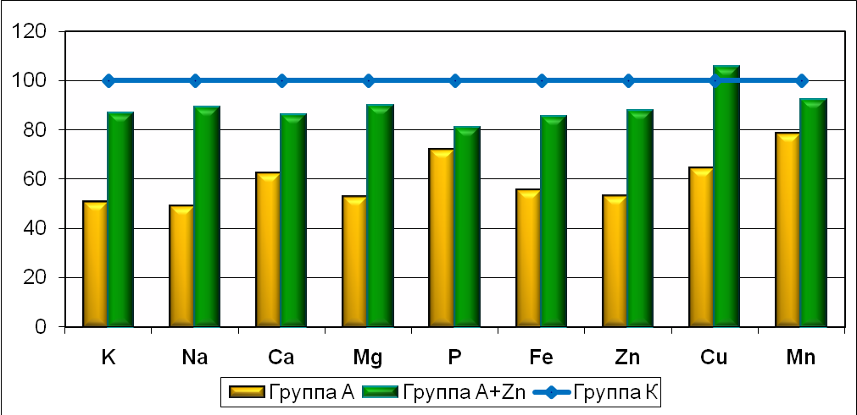
Group A+Zn
Group K
Group A
*
*
*
*
*
**
**
**
**
**
Figures 8., Concentrations of macro- (Ca, Mg, P, K, Na) and microelements (Fe, Zn, Cu, Mn) in the brain cortex tissue samples of mature progenies of the female rats that were exposed to alcohol before mating with intact males with subsequent zinc administration during the bearing and breast-feeding periods (%). note: * stands for р < 0,05 – significance level (comparing to A-group).
А.V. Skalnyi (1990) reported experimental data showing that normalization of the mineral metabolism within the brain cortex after zinc sulfate administration can be a cause of significantly less severe impairments of the central nervous system in mature progenies, particularly concerning the cognitive activities and behavioristic reactions (cross-shaped labyrinth tests after zinc sulfate administration) when comparing to the mature progenies received from alcohol-exposed female rats that did not receive zinc sulfate during bearing and breast-feeding.
The brain white matter tissue samples of the group A+Zn rats did not show significant differences in ChE concentrations when comparing to the А group at rats (Fig.9). No significant differences were observed even when comparing ChE concentrations of А+Zn rats to the control group of animals.
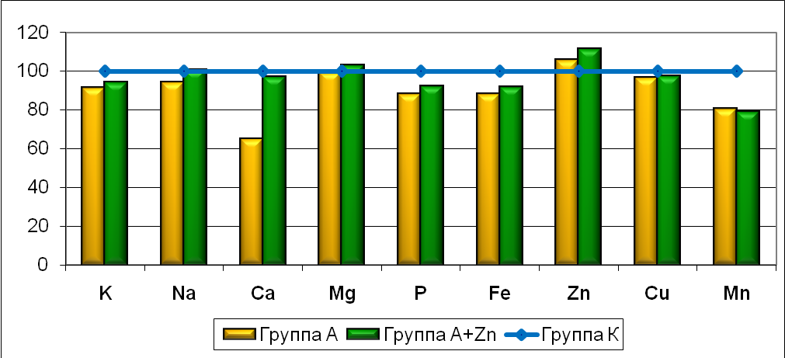
Group K
Group A+Zn
Group A
*
*
*
*
Figure 9. Concentrations of macro- (Ca, Mg, P, K, Na) and microelements (Fe, Zn, Cu, Mn) in the brain white matter tissue samples of mature progenies of the female rats that were exposed to alcohol before mating with intact males with subsequent zinc sulfate administration during the bearing and breast-feeding periods (%). note: * stands for р < 0,05 – significance level (comparing to K-group); ** - stands for р < 0,05 – significance level (comparing to A-group).
These data apparently enable to consider the normalization of the minerals metabolism within the brain white matter of the А+Zn group of animals, but it is still unclear whether it is caused by consuming zinc sulfate water solution (as the only source of liquids) during mating, bearing and breast-feeding.
The cerebellum tissue samples Mn levels of the А+Zn group of rats were significantly higher then the ones in the A group of rats, but no significant differences were observed when comparing to the control group of rats (Fig. 10), which enables to state that normalization of the Mn concentration is surely caused by zinc sulfate administration.
It is essential to point out that A+Zn group of rats had significantly elevated levels of K, Na, Zn and Fe in cerebellum tissue samples with a decreasing tendency for Mg, P and Cu levels when comparing to К group of rats; in addition to that the Mn values in A-group of rats (cerebellum tissue samples) were significantly lower, with significantly higher levels of Zn. This shows that corrective treatment with the use of zinc sulfate causes macro- and microelements accumulation with a normalization of Mn concentration in the cerebellum.
The hippocampus tissue samples of А+Zn group of rats presented similar data – the levels of Mn were elevated in the same manner (reaching the level obtained in the control group). That means – zinc sulfate administration to the female rats (after the alcohol exposure) caused normalization of the Mn values in hippocampus tissues of the progenies (just like it was in cerebellum tissue samples). Besides this, the hippocampus samples have shown significantly higher levels of Na, Mg, Zn with an increasing tendency for К values; significantly higher levels of K, Mg, Zn and Cu (as well as an increasing tendency for Ca and Na levels) were shown when comparing to the control group of rats (Fig. 11).
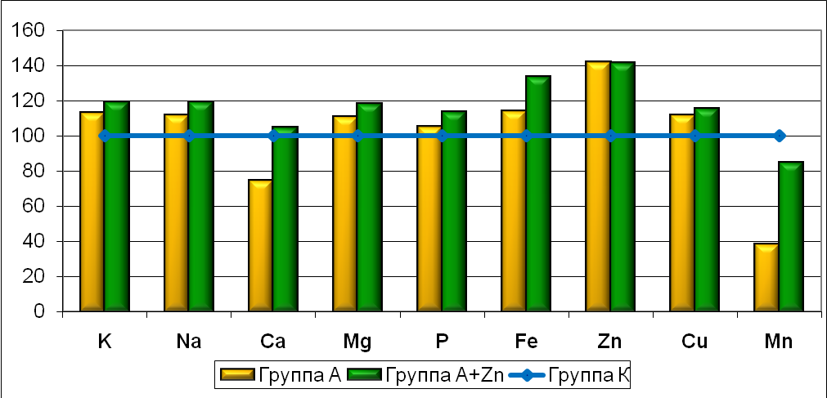
Group K
Group A+Zn
Group A
*
*
*
**
*
*
*
Figure 10. Concentrations of macro- (Ca, Mg, P, K, Na) and microelements (Fe, Zn, Cu, Mn) in the cerebellum tissue samples of mature progenies of the female rats that were exposed to alcohol before mating with intact males with subsequent zinc sulfate administration during the bearing and breast-feeding periods (в %). note: * stands for р < 0,05 – significance level (comparing to K-group); ** - stands for р < 0,05 – significance level (comparing to A-group).

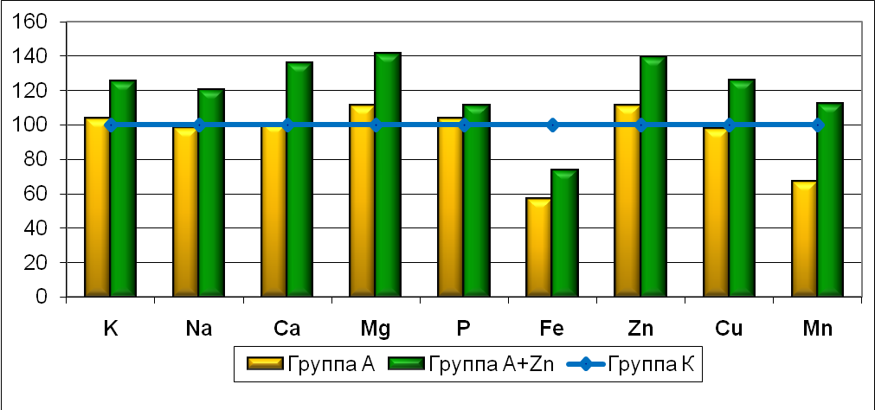
Group K
Group A+Zn
Group A
*
*
**
*
**
* **
* **
Figure 11. Concentrations of macro- (Ca, Mg, P, K, Na) and microelements (Fe, Zn, Cu, Mn) in the hippocampus tissue samples of mature progenies of the female rats that were exposed to alcohol before mating with intact males with subsequent zinc sulfate administration during the bearing and breast-feeding periods (%). note: * stands for р < 0,05 – significance level (comparing to K-group); ** - stands for р < 0,05 – significance level (comparing to A-group).
That indicates the normalization of the K, Na, Mg, Fe and Zn levels within the brain cortex tissue samples, as well as Mn level normalization within the cerebellum and hippocampus tissue samples of the mature progenies; the normalization is caused by the zinc sulfate introducing to the alcohol-exposed female rats (during mating, bearing and breast-feeding). The obtained data enable to consider that in mature progenies of the pre-conceptionally alcohol-exposed female rats that were consuming zinc sulfate for the whole bearing and breast-feeding, there are signs of metabolic and physiologic processes activation within the hippocampus and the cerebellum tissues, the degree of which is greatly influenced by ChE concentrations (which are significantly elevated).
A very important role in developing a certain bioelementary status belongs to different regulatory mechanisms of chemical elements interactions, as they intensively interact with each other, as well as with other biologically active substances. These interactions cause the development of the synergic and antagonistic effects. Taking this into consideration, it is necessary to pay attention to reaching the optimal proportions for macro- and microelements that synergically or antagonistically affect different physiological parameters (Barashkov G.К., 2007; Petukhov V.I. et al., 2008). The significant degree of sensitivity in neencephalon elements of the brain (primarily – the brain cortex) comparing to the paleoencephalon elements, is quite understandable from the modern biology perspectives: evolutionally more complicated creatures and complicated tissues are especially vulnerable to toxic impairments.
The administrating of the zinc formulations causes protective effects within the mother-fetus system, which is expressed by partial compensation of the macro- and microelements disproportions in the progenies after exposing alcohol to mothers. As literature review data show, zinc claims to be the key «universal» regulatory factor for many metabolical processes within the organism due to its significant role in a great amount of enzyme systems, apoptotic processes, cellular proliferative processes, etc. (Prasad A.S., 2009). The literature review data enable to confirmthat zinc is a proper medication for correcting polimicroelementosis (Skalnyi А.V., Ignatova S.А., Losev А.S, 1996).
As many foreign and national scientists suppose, the disproportions of ChE concentrations within tissues and organs are to be considered indicative for metal-ligand homeostasis impairments (Gladskih S.P., Sernov L.N., 2002; Barashkov G.К., 2007; Petukhov V.I. et al., 2008). That makes research activities in the field of ChE proportions assessment more and more important, especially for ChE that act as functional antagonists, for in such cases even slight but oppositely directed absolute ChE values deviations may become clinically of physiologically significant (Panchenko L.F., Mayev I.V., Gurievich К.G., 2004; Oberlis D. et al., 2008). That is why we chose to assess certain elemental proportions: macro-elements Mg/Ca, P/Ca, K/Na, microelements - Zn/Cu, Fe/Zn and Cu/Mn, all of these proportions are specific and indicative for defining the metall-ligand homeostasis parameters (modern bio-inorganic chemistry) (Barashkov G.К., 2007; Pleteneva Т.V. et al., 2009).
According to the data obtained during our research work, the group А rats (comparing to the control group of animals) presented signs of significant increase of P/Ca ratio in the kidney tissues, signs of significant decrease of the K/Na ratio in seminal glands, as well as increasing tendencies for Cu/Mn ratio in hepatic and renal tissues plus increasing tendency for Mg/Ca ratio in the cardiac muscle. Other assessed ChE proportions in the tissue sample of the A-group had no significant differences when comparing to the K-group values.
The deviation of the relative parameter – P/Ca proportions – indicates possible phosphorus and calcium homeostasis disturbances in the investigated animals (group A), a consequence of which is an activation of renal calcium excretion with phosphorus accumulation in the kidney tissues.
It is important to note that an increasing tendency was observed for Mg/Ca ratio in the cardiac muscle. The Mg²⁺ ions are the physiological antagonists of Ca²⁺ ions. The antagonism with Ca²⁺ ions explains the phenomenon of Mg²⁺-activated ADP-induced thrombocytes aggregation with inhibiton of other Са-mediated reactions during coagulation processes (Gorodetskiy V.V., 2003).
Copper is functional antagonist of Zn, especially with an alcohol exposure background (Skalnyi А.V., 1990). That is why defining the Zn/Cu ratio is important for a proper assessment of alcohol exposure effects in the organism (mostly in hepatic tissues), for these microelements are the components of the basic enzymes that take part in the alcohol metabolism (the most part of alcohol is being metabolized in the hepatic tissues). However, we failed to detect statistically significant deviations of the Zn/Cu ratio.
The ratios (coefficients) of chemical elements containment could possibly help understanding, what processes take place in different brain structures of the mature progenies received from female rats that were exposed to alcohol before mating with intact males. According to G.N. Kryzhanovskiy (2002), the observed deviations of the minerals metabolism in the progenies of alcohol-exposed female rats are defined as disregulatory disorders (a pathological process that develops after a disregulation of the functional parameters in cells, organs, tissue systems and the whole organism).
After performing our research work, we detected significant deviations of the ChE ratios within the brain structures. After analyzing the macro- and microlements ratios (in the brain cortex) we found out that in A group of animals the K/Na ratio was significantly higher, on the other hand, this ratio was significantly lower in the А+Zn rats. The Cu/Mn ratio was also significantly lower in the А group. The brain white matter ratios of Mg/Ca and P/Ca in this group of rats were elevated with a decrease in the Fe/Zn ratio. The zinc sulfate corrective therapy did not cause statistically significant normalization of these ratios. The cerebellum and hippocampus tissue samples if the A-group rat presented similarly deviated ratios: Fe/Zn is decreased; Cu/Mn ratio is increased, whilst the Cu/Mn ratio is prone to decreasing after zinc sulfate administrating (becoming similar to the values detected for the K group). Besides that, the cerebellum tissue samples presented elevated Zn/Cu ratio (for the rats in the А group when comparing to the control group of rats).
In the investigated brain structures (with a certain number of exclusions) a major modality is clearly visible: the macro- and microelements deviations (when comparing to the control group of values) either decrease or increase in the A-group of animals (multidirectional deviations), and the investigated parameters in the animals of the А+Zn group are prone to relative normalization.
The obtained data of the experimental part of the investigation enables to suppose that the effect of pre-conceptional alcohol exposure to mothers is significant and that it surely affects the metabolical processes in the organism of mature progenies. The analysis of the obtained data shows that pre-conceptional alcohol exposure to the females induces chemical elements disproportions in mature progenies (disproportions take place in the central nervous system and internal organs that actively metabolize alcohol). Alcohol exposure to females before mating with intact males induces absolute and relative disproportions of the ChE concentrations within internal organs and central nervous system structures. It has been shown that there is a possibility of diselementosis correction treatment for different brain structural elements of the mature progenies after the zinc sulfate introducing to the mother’s organism during mating, bearing and breast-feeding. The introduction of the zinc sulfate to mother’s organism causes the increase in ChE concentrations within the brain structural elements, while the ChE disproportions are multidirectional (but prone to normalization).
Conclusions

- In mature progenies of the female rats that were preconceptionally exposed to alcohol, the detected deviations within the hepatic tissues, the kidneys and the cardiac muscle are shown only for macroelements (elevated K, Na, Ca levels for liver, P – for kidney tissues, K – for cardiac muscle). These data enable to consider that the probability of disturbances development within the stated organs (liver, urine excretion system and cardiovascular system) is due to the significant role of the stated elements in the functional regulation within the stated organs. Alcohol exposure to rat females before mating did not affect the ChE concentrations within the seminal glands and skin tissues of the mature progenies.
- In mature progenies of the female rats that were preconceptionally exposed to alcohol, the brain cortex samples data showed decreased levels of Na, Mg, К, Fe and Zn, the cerebellum tissues are low on Mn and high on Zn; hippocampus tissue samples have decreased Mn levels; the brain white matter is low on Ca, P, Fe and Mn. The detected deviations could be a reason of neuronal impairment, hyperirritability, cognitive disorders and muscular tissue regulation disorders.
- Zinc sulfate water solution administering after the alcohol consumption cancellation during mating, bearing and breast-feeding causes normalization of the K, Na, Mg, Fe, Zn levels (brain cortex) in the mature progenies, as well as it normalizes Mn level within the cerebellum and hippocampus tissues. The assessment of cerebellum ChE concentrations shows increased levels of К, Na and Fe, as well as К, Mg and Zn levels in the hippocampus tissues.
- The chemical elements disproportions (especially concerning the elements which are functionally antagonistic) within the hepatic tissues, the cardiac muscles and the kidney tissues indicate a deviation of water-mineral and calcium-phosphorus metabolism in the organism, while in the brain structures the detected deviations affect synthesis and metabolism of the neuromediators. The administration of zinc sulfate causes multidirectional changes of the chemical elements concentrations within the brain structures of the mature progenies, but mostly these changes are prone to normalization.
- The obtained results surely indicate the development of the significant deviations of the macro- and microelements metabolism in the mature progenies of the female rats that were exposed to alcohol before mating with intact males, as well as the obtained results enable to consider that the absolute and relative deviations of the chemical elements data significantly affect the metal-ligand homeostasis and, thus, promote the development of the functional disorders.
List of related publications
- Vyatchanina E.S., Skalnyi А.V. The protective effects of the zinc sulfate after an intrauterine exposure to alcohol // Orenburg State University Bulletin. – 2007. - №12 (79). - pp. 113-116.
- Skalnyi А.V., Kurchashova S.Yu., Vyatchanina E.S. Zinc and other microelemental disproportions – the role in alcoholism pathogenesis and alcohol-induced embyo-fetopathies in the Russian Federation// Narcology. – 2008. - №5 (77). – pp. 26-33.
- Vyatchanina E.S., Skalnyi А.V. The alcohol exposure effects on the nervous system of the progenies, particularly the influence on neuroimmune processes and chemical elements disproportions // Rehabilitational medicine Bulletin. - 2008. - №5А (28). - pp. 17-22.
- Vyatchanina E.S. The impairments of the chemical elements metabolism within the central nervous system of the progenies in cases of chronic alcohol intoxication among parents and SSB within the mother-fetus system // Immunopathologic and pathobiochemical aspects in cases of brain perinatal impairment: pathogenesis. – Saint-Petersburg: «Nauka» (Science), 2009. – pp. 141-167.
- Семенов А.С., Skalnyi А.V., Vyatchanina E.S. The analysis of ChE metabolic disturbances within the central nervous system of the progenies in cases of chronic alcohol intoxication and SSB among the alcohol-exposed rats. The CNS corrective therapy with the use of zinc sulfate) // Immunopathologic and pathobiochemical aspects in cases of brain perinatal impairment: pathogenesis. – Saint-Petersburg: «Nauka» (Science). – С.168-193.
Semenov A.S.,
- Vyatchanina E.S., Skalnyi А.V. The effect of pre-conceptional alcohol exposure in mothers on the chemical elements profile within the brain cortex of the progenies // Materials of the First Russian and International Narcology Congress (Moscow, November 2009). – М. – pp. 7-8.
- Skalnyi А.V., Kin К.L., Chambers К.D., Ogotoeva S.N., Vyatchanina E.S. The zinc metabolism impairment in cases of intrauteral alcohol exposure // Materials of the First Russian and International Narcology Congress (Moscow, November 2009). – М. – pp. 18-19.
- Skalnyi А.V., Vyatchanina E.S. The effects of chronic alcohol intoxication on zinc and copper metabolism in animal models// The materials of All-Russian Scientific Research Conference with international cooperative participation «Physiologic and Hygienic problems of the human ecology» (Belgorod, May2007). – Belgorod: “BSU” publishing house (BGU), 2007. - pp. 107-109.
- Skalny A., Vyatchanina E. Zn protects derangement of alcoholized rat brain macro- and trace elements (TE) content // Cell. Biol. Toxicol. – 2008. – V.24. - (Suppl 1). - S68-69.
- Vyatchanina E.S. Preconception alcohol intoxication disturbs the offspring's brain metal distribution // Trace elements in medicine №11 (2). - Special issue, 4th International Symposium on Trace Elements and Minerals in Medicine and Biology (Russia, St.Petersburg, June 2010). – 2010. – P. 63.

